- Copyright for test papers and marking guides remains with West Australian Test Papers.
- The papers may only be reproduced within the purchasing school according to the advertised conditions of sale.
- Test papers must be withdrawn after use and stored securely in the school until Wednesday 5th December 2012.

PHYSICS

YEAR 11

STAGE 2A/2B

2012



Name: _______________________________________________________

Teacher: ___________________________________________________

TIME ALLOWED FOR THIS PAPER

Reading time before commencing work: Ten minutes
Working time for the paper: Three hours

MATERIALS REQUIRED/RECOMMENDED FOR THIS PAPER

To be provided by the supervisor:
- This Question/Answer Booklet; Formula and Constants sheet

To be provided by the candidate:
- Standard items: pens, pencils, eraser or correction fluid, ruler, highlighter.

- Special items: Calculators satisfying the conditions set by the Curriculum Council for this subject.

IMPORTANT NOTE TO CANDIDATES
No other items may be taken into the examination room. It is your responsibility to ensure that you do not have any unauthorised notes or other items of a non-personal nature in the examination room. If you have any unauthorised material with you, hand it to the supervisor before reading any further.

All calculations are to be set out in detail. Marks may be awarded for correct equations and clear setting out, even if you cannot complete the calculation. Express numerical answers to two (2) or three (3) significant figures and include units where appropriate. Express estimates to one (1) or two (2) significant figures, and state any assumptions clearly.

STRUCTURE OF THE PAPER

Section | No. of  Questions | No. of questions  to be attempted | No. of marks  out of 200 | Proportion of  exam total
A: Short Answers | 15 | ALL | 80 | 40%
B: Problem Solving | 8 | ALL | 100 | 50%
C: Comprehension and  Interpretation | 1 | ALL | 20 | 10%

Note: Above refers to 3 hour paper.

INSTRUCTIONS TO CANDIDATES

Write your answers in the spaces provided beneath each question. The value of each question (out of 200) is shown following each question.

The enclosed Physics: Formulae and Constants Sheet may be removed from the booklet and used as required.

Calculators satisfying conditions set by the School Curriculum and Standards Authority may be used to evaluate numerical answers. The calculator cannot be a “graphics” calculator.

Answers to questions involving calculations should be evaluated and given in decimal form. Final answers should be given to two or three significant figures and include appropriate units where appropriate. Despite an incorrect final result, credit may be obtained for method and working providing these are clearly and legibly set out.

Questions containing specific instructions to show working should be answered with a complete, logical, clear sequence of reasoning showing how the final answer was arrived at; correct answers which do not show working will not be awarded full marks.

Questions containing the instruction "ESTIMATE" may give insufficient numerical data for their solution. Students should provide appropriate figures to enable an approximate solution to be obtained.

Section A: Short Answers

Marks allocated: 80 marks out of a total of 200 (40%)

Attempt ALL questions in this section. Not all questions attract the same marks.

Answers are to be written in the space below or next to each question.
Question 1
a) A warm bottle of water at room temperature is placed in a refrigerator that has its temperature control set to 4.0 ºC. Describe the physics principles involved in the refrigerator design and the process whereby the drink becomes cooler by being placed in the refrigerator for a while. (3 marks)

b) Why doesn’t the drink freeze even if it is left under these conditions for a long time? (1 mark)

Question 2
a) A tennis ball is hit vertically into the air with an initial velocity of 75.0 m s⁻¹ and returns to the exact position from which it was hit. If air resistance is ignored, explain why the time for its ascent is equal to the time for descent. (2 marks)

b) At the exact time the ball reaches its greatest height, what is its:

- Velocity?

- Acceleration? (2 marks)

Question 3
a) When electric current flows through a tungsten filament in an incandescent globe the filament
becomes white hot. How does the resistance in the filament differ from the resistance in the
wires that connect the globe to the mains supply? (2 marks)

b) Incandescent globes are gradually being replaced with “compact fluoro” globes that are said
to be more environmentally friendly. What characteristics of the “compact fluoro” globes
make them more environmentally friendly? (2 marks)

Question 4
In terms of electrical theory, explain how a “dimmer” switch that is connected to a household
circuit can be used to control the brightness of lights in the house. (3 marks)

Question 5
An International golfer hit his golf ball from the tee at full speed. This is called a drive.
In the parts to this question list any ESTIMATES you make before completing the question.

a) ESTIMATE the change in momentum of the golf ball during his drive. (2 marks)

b) If his golf club had a mass of 450 g and the contact time of the ball on the club
was 0.20 s then what force would the golfer provide? (2 marks)

c) Why do you think golfers often have shoulder injuries? (1 mark)

Question 6
The diagram below represents a network of resistors.
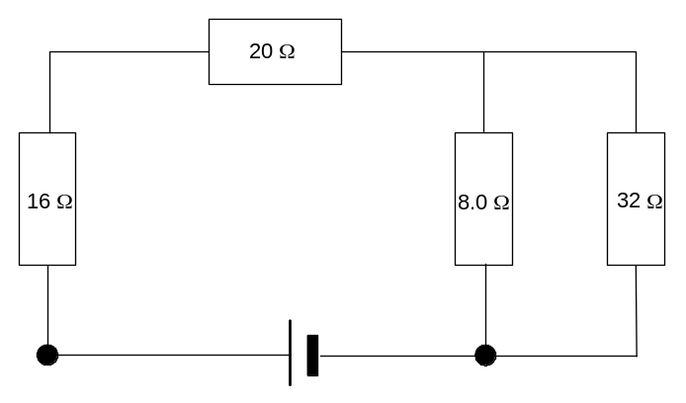
a) What is the total resistance of this network? (3 marks)

b) Which resistor(s) will carry the largest current? Explain your answer (2 marks)

Question 7
7. Solar hot water systems are installed on many houses in Western Australia.

a) Suggest a reason why Western Australia is a suitable place to install solar hot water systems? (2 marks)

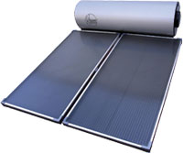

b) The intensity of the sun is approximately 850 W m⁻² and a typical heater would have an area
of about 2.0 m². Calculate the temperature increase in 45.0 min if the mass of water in the
pipes in the panel is 17.0 kg. (3 marks)

c) For the above calculation to be realistic, a major assumption about the water in the heater has
been made. Suggest what that assumption may be. (2 marks)

Question 8
A wooden relic having a mass of 0.50 kg is discovered during an archaeological dig. When tested with a Geiger counter it registers 560 counts in 1.00 hour. The relic is compared to a 0.50 kg reference piece of carbon which produces 0.311 Bq of ionizing radiation.

(The half-life of radioactive carbon is 5720 years)

- What is the activity of the relic’s radiation in becquerals (Bq)? (2 marks)

b) Is the relic older or younger than the reference piece? Explain how you arrived at your
answer. (3 marks)

c) Why is the element carbon used to “date” archaeological relics? (2 marks)

Question 9
The graph below represents the motion of a car of mass 1.50 x 10³ kg travelling in a straight line

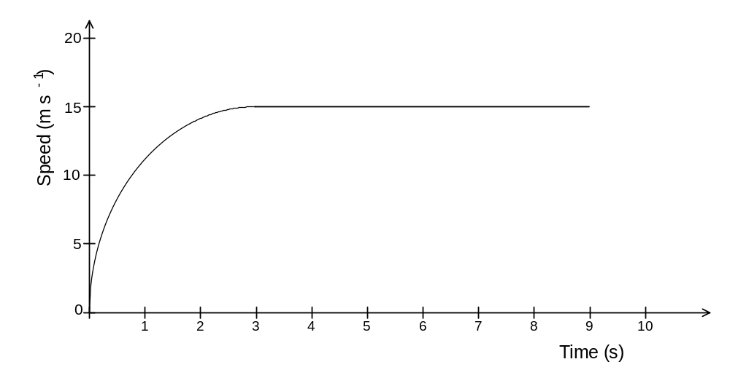
- Calculate the average acceleration of the car during the first 2.50 s of its motion
(2 marks)

b) What average force is required during the first 2.50 s to provide the acceleration calculated
in (a)? (3 marks)

c) When the car reaches its constant speed, a force of 2.50 x 10³ N is required to keep it moving. Calculate the power output of the car to maintain this speed. (3 marks)

Question 10
a) Complete the following nuclear equations and name the particle / radiation type.
(2 marks)
(i) 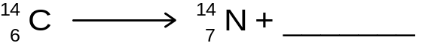 Name of particle___________________
(ii) 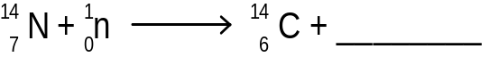 Name of particle___________________

b) Write balanced nuclear equations for the following decays. (2 marks)

- Iodine -131 by beta negative decay.

(ii) Radon – 220 by alpha decay.

Question 11
The world record for the men’s 100.0 m sprint is about 9.0 s.
On the speed versus distance graph below, represent the speed of a world-class athlete as
he runs the 100.0 m sprint. Label the axis and include scales for speed and distance (3 marks)

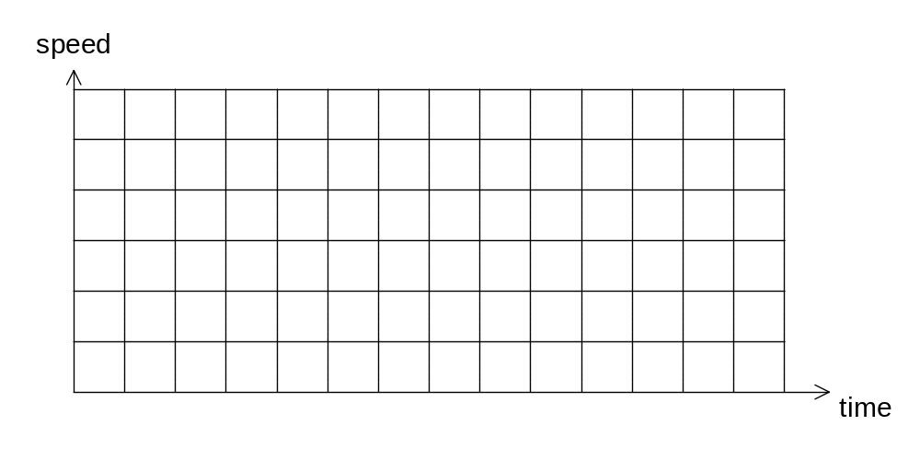

Question 12
A cyclist wants to take a bottle of cold water on a long ride .To prepare the water she places 750 mL of tap water at 22.0 ºC in an insulated bottle and adds ice at 0 ºC. When all the ice has melted the temperature of the water is 5.0 ºC.

a) What mass of ice at 0 º C should she add? (4 marks)

b) Describe one action the cyclist could take to ensure the water stayed colder for a longer time. (2 marks)

Question 13
A coffee machine that makes cappuccinos heats 5.00 g of water from 25.0 ºC to 100.0 ºC and converts the water to steam, which is used to heat milk by squirting it into a mug containing the milk.
Assuming no energy is lost to the surroundings, calculate the electrical energy required to:

a) change the temperature of 5.00 g of water in the machine from 25.0 ⁰C to 100.0 ⁰C. (3 marks)

b) convert the heated water into steam. (2 marks)

c) If the coffee machine is connected to the mains (240 V) how long will it take the machine to
produce the total energy to heat the water and convert it to steam if the heating coil in the
machine has a resistance of 50.0 ohms? (4 marks)

Question 14
The following graph represents the data collected by measuring the radioactive activity as a function of time.

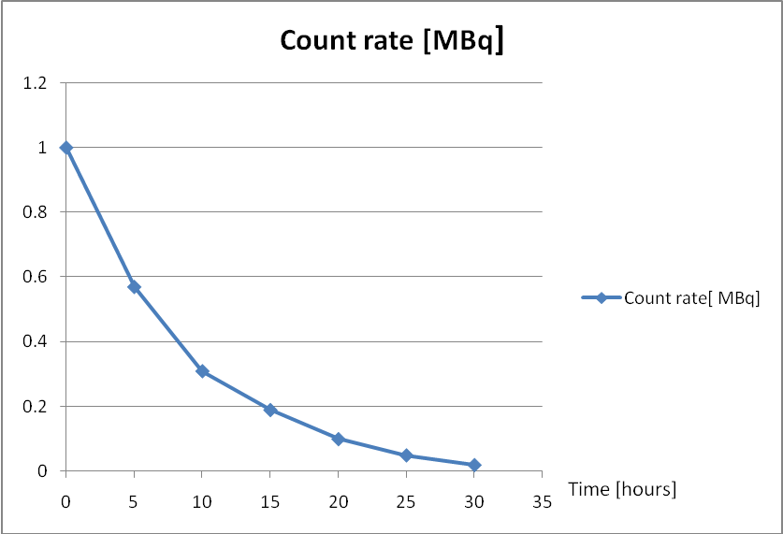

a) Using the graph calculate the half-life, T_{1/2} of this decay. (3 marks)

b) Predict the activity after a time interval of four half lives. (2 marks)

Question 15
The diagram (inset) below shows a potentially hazardous situation where the live wire has become detached from the motor and touches the metal casing of the washing machine, causing a short circuit.

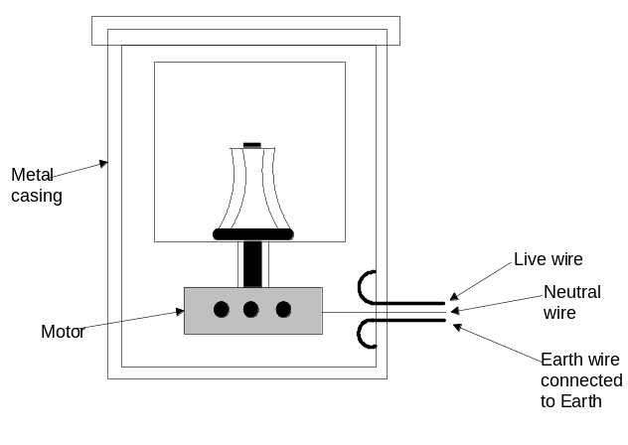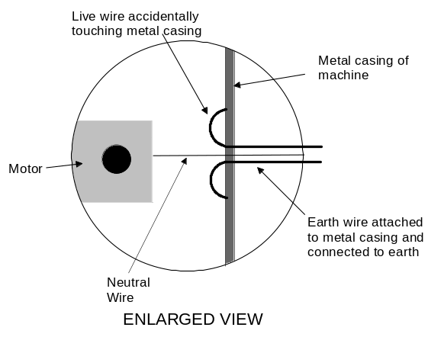

Two students are asked to predict what will happen when a person touches the ‘live’ casing.
One student says that nothing will happen to the person.
The other student says the person will receive a severe electric shock.
Explain differing circumstances that exist in each case for both students’ to be correct. (6 marks)

END OF SECTION A

Section B: Problem Solving

Marks allotted: 100 marks out of a total of 200 (50%)

This section contains 8 questions.

Answer the questions in the spaces provided.

Question 1 (13 marks)
Part of an assembly line in a factory contains a ramp which is used to shift boxes from one level to another. The ramp is 5.00 m long and is designed to provide a constant friction force of 30.0 N on the 40.0 kg boxes as they slide down it.
The diagram below shows the dimensions of the ramp.

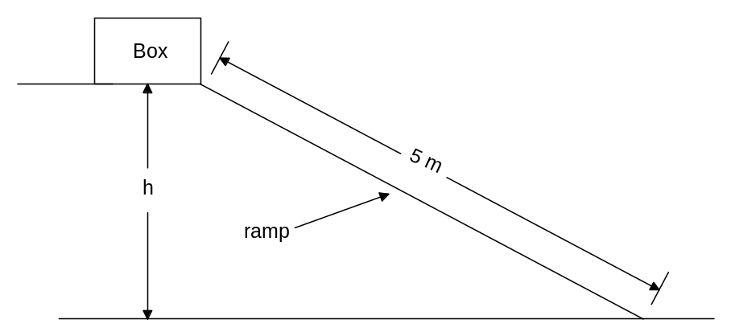
A box is loaded onto the top of the ramp and slides from rest to the level below. It reaches the end of the ramp with a speed of 6.00 m s⁻¹.

a) Determine the kinetic energy of the box at the bottom of the ramp. (2 marks)

b) Calculate the vertical height (h) of the ramp. (4 marks)

c) Is the potential energy at the top of the ramp equal to the kinetic energy at the bottom?
Explain your answer. (2 marks)

d) Despite the presence of the constant frictional force, will the boxes accelerate as they travel
down the ramp? Explain your answer. (2 marks)

e) If a box is accidently dropped from the top of the ramp and falls to the level below, calculate
the velocity with which it hits the lower level. (3 marks)

Question 2 (12 marks)
The nuclear disaster at the Fukushima Daiichi nuclear plant in Japan produced fallout over a wide area of the country. A person close to the plant was accidently exposed to the fallout and absorbed 70.0 J of beta radiation. If the person had a mass of 65.0 kg:

a) determine the absorbed dose. (2 marks)

b) determine the dose equivalent. (2 marks)

c) determine the dose equivalent if the source had been an alpha source. (2 marks)

d) what effects would this exposure to beta and alpha radiation have on the person’s health? (1 mark)

e) The beta radiation that the person absorbed originated from an isotope that had a half-life of
120 years and its original activity was 1000 MBq

(i) Draw a graph to show how its activity would change over a period of 360 years.
(3 marks)



(ii) From the graph, or otherwise, calculate the activity after 300 years. (2 marks)

Question 3 (13 Marks)
Nuclear energy can be produced in a nuclear reactor by bombarding uranium – 235 with neutrons. As well as large quantities of energy, barium – 144, krypton – 89 and neutrons are produced as
by-products of the reaction.

Rest masses:
Barium-144 = 2.34 x 10⁻²⁵ kg
Krypton-89 = 1.52 x 10⁻²⁵ kg
Uranium-235 = 3.90 x 10⁻²⁵ kg

a) Write a nuclear equation to represent this fission reaction. (2 marks)

b) How much energy is released by the fission of ONE uranium nucleus? (5 marks)

c) Calculate the mass of U-235 needed to produce 200 MW of power for one year (365 days). (6 marks)

Question 4 (15 marks)
Below is a diagram of an electrical circuit set up by a teacher to test students’ understanding of voltage, current and resistance. The circuit consists of resistors connected to a battery with a stated emf of 120.0 V.

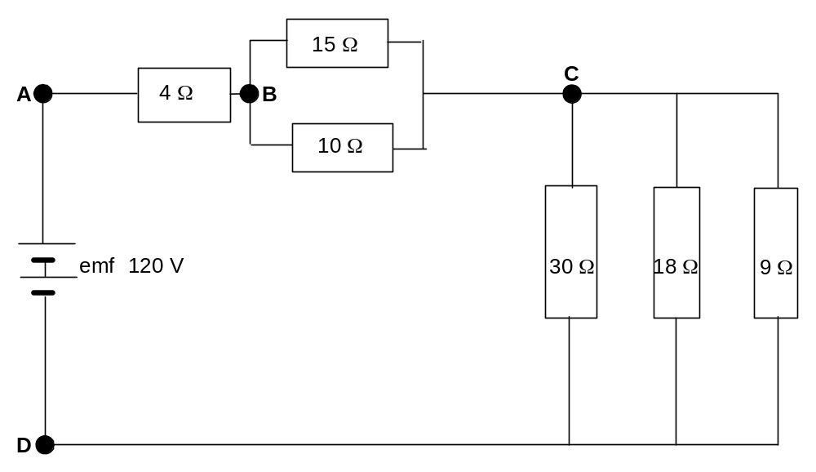
a) Calculate the effective total resistance of the circuit. (3 marks)

b) Determine the current in the circuit at point A (2 marks)

c) Calculate the voltage drop across the 4 ohm resistor. (2 marks)

d) If the current is measured at point B, what will its value be? (1 mark)
- 2/3 of that measured at A
- The same as measured at A
- 1.5 times that measured at A
- ¼ of that measured at A?
Place your answer (A, B, C or D in the box opposite

e) Explain why you chose your answer to (d) above. (2 marks)

f) Calculate the quantity of charge that flows through the circuit in 2 minutes. (2 marks)

g) The battery can supply 1.50 MJ of energy. For how long could this battery operate if it constantly supplies this quantity of energy? (3 marks)

Question 5 (10 marks)
As a laboratory exercise students were set the task of determining the latent heat of
vaporisation of water. They were provided with all the necessary equipment to perform the
experiment. They followed the steps listed below.

1 A styrofoam cup was weighed. Its mass was 3.00 g
2 A quantity of distilled water was placed in the cup.
3 The cup plus water was reweighed and the new mass was 208 g.
4 The temperature of the water was then taken and recorded as 21.0 ^{c}C
5 A quantity of distilled water was then placed in a conical flask, which had a glass delivery tube, fitted to it.
6 The conical flask was heated on a hot plate to boil the water and produce steam.
7 The steam was passed through the delivery tube and bubbled into the styrofoam cup containing the distilled water.
8 The temperature of the water in the styrofoam cup was monitored as the steam was bubbled into it.
9 When the temperature reached 80.0 ºC the delivery tube was quickly removed and the styrofoam cup and water was weighed. The mass of the cup and its contents was
230 g.

- Using the data collected by the students, calculate the latent heat of vaporisation of water. (4 marks)

- The accepted value for the latent heat of vaporisation of water is 2.26 x 10⁶ J kg⁻¹. Calculate
the percentage error in this experiment. (2 marks)

- Given the method performed and the equipment used do you think this is an acceptable result?
Explain your answer. (2 marks)

- The students used a 40 cm long delivery tube between the conical flask and the styrofoam
cup. Explain why the relatively long tube could affect the accuracy of the experiment. (2 marks)

Question 6 (14 marks)
a) A Cessna aircraft operating out of Jandakot airport has a total mass, including the pilot, of
2150 kg when loaded. During take off it travels 200 m and reaches a speed of 85 km h⁻¹
before leaving the runway. Determine the momentum of the Cessna when the aircraft just
leaves the runway (2 marks)

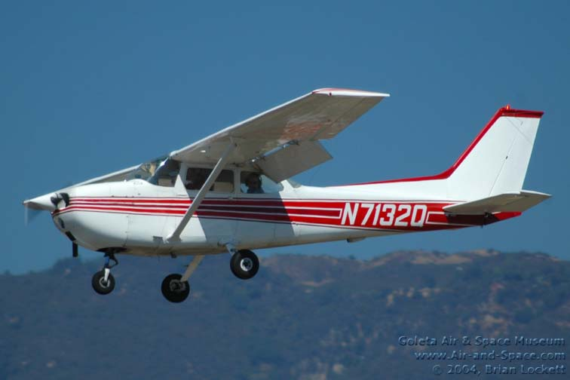

b) Calculate the average force acting on the 80.0 kg pilot as the aircraft accelerates along the runway. (3 marks)

c) Would you expect the average force calculated in (b) above to be constant as the aircraft
accelerates before take off? Explain your answer. (2 marks)

(d) When the aircraft reaches an altitude of 2.0 km it levels off and flies horizontally into a
headwind of 20.0 km h⁻¹. At what average speed will the aircraft need to fly if it is to reach a
destination 150.0 km away in a time of 1 hour? (3 marks)

e) At its destination the aircraft touches down with a horizontal speed of 16.0 m s⁻¹ and
decelerates at a rate of 2.00 m s⁻² . How far has it travelled before stopping? (2 marks)

(f) Calculate the average force the engine needs to produce to decelerate the aircraft as it comes
to rest. (2 marks)

Question 7 (8 marks)

Below is a heating graph for an unknown substance. The graph is the result of collecting data when 10.0 g of the solid substance was heated until it vaporised. Examine the graph and answer the following questions.

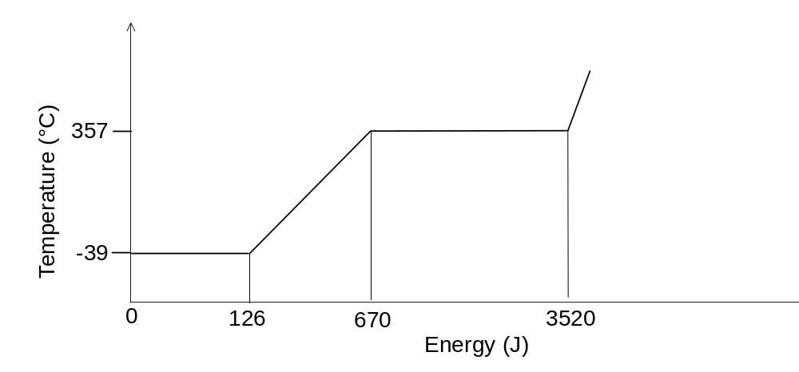

- Explain why the temperature remains constant during the first part of the graph.
(1 mark)

- At what temperature does the substance melt? (1 mark)

- At what temperature does the substance boil? (1 mark)

- Calculate the latent heat of fusion of the substance? (2marks)

- Calculate the latent heat of vaporisation of the substance? (2 marks)

- Is the unknown substance water? Explain your answer. (1 mark)

Question 8 (15 marks)
a) When a plastic rod is rubbed with a cloth it can become negatively charged. Explain, using
electrostatic principles how the plastic rod becomes charged. (2 marks)

b) When a charged rod is bought close to small pieces of paper they are attracted to it.
Explain in terms of electrostatics how this occurs. (2 marks)

c) After a short time the paper is observed to fall from the rod. Explain why this happens. (2 marks)

d) Explain why it is impossible to charge a copper rod by rubbing it with a similar cloth. (2 marks)

e) Below is a diagram of two charged plates. A proton is at rest on the positive plate. On the
diagram draw arrows to show the position and direction of the electric field associated with the plates. (2 marks)

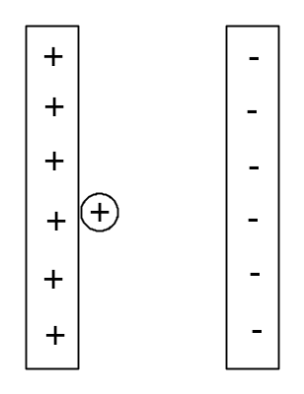

f) If the potential difference between the plates is 12.0 V, calculate the maximum speed that
the proton will reach in this potential difference. (5 marks)

END OF SECTION B

Section C: Comprehension and Interpretation

Marks allotted: 20 marks out of 200

Question 1 (20 marks)

The Red Bull company is sponsoring a sky dive from a very high altitude. In 1960 Joe Kittinger jumped from 31 000 m and survived the ordeal. The latest attempt will involve Felix Baumgartner, (The Red Bull Dude), taking a balloon ride up to 36 500 m and jumping out!! Some questions have been raised by an amateur skydiver about Felix’s ability to successfully complete the jump. In an attempt to predict the difficulty of the jump, the amateur skydiver has done some calculations of his own. For instance he has raised the question of air resistance. The air resistance model:

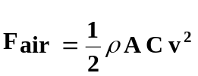
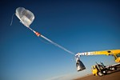
where:

F_{air} is air resistance
ρ is the density of air
A is cross sectional area of diver
C is the coefficient of shape of diver
v is the velocity of the diver

has been used to calculate Felix’s velocity.


When data is entered into the air resistance model, Felix’s velocity has been calculated as a function of time for the fall to earth.
Apart from Felix’s velocity during the jump, the sponsors are interested to compare his speed with the speed of sound to see if he breaks the sound barrier on the way down.
Because the speed of sound is temperature dependant, the following formula can be used to calculate the speed of sound for any temperature.

v_{sound} = (331.3 + 0.606 T) where

v_{sound} is the velocity of sound and
T is the celsius temperature,

The graph below shows how Felix’s proposed velocity compares with the corresponding speed of sound.

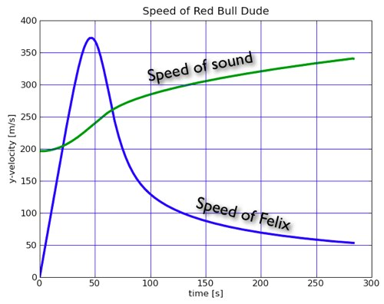

A second graph showing height versus time has been produced by the amateur skydiver (see below)

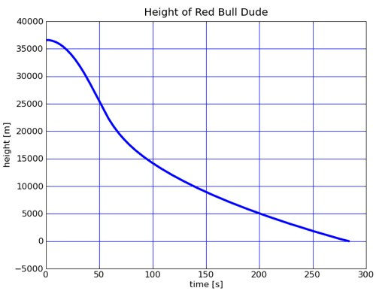

Questions
- According to the graphs how many seconds will it take for Felix’s velocity to reach the
speed of sound? (2 marks)

- At what velocity will Felix be travelling when he first travels at the speed of sound? (2 marks)

- For how long will Felix travel at a speed greater than the speed of sound? (2 marks)

4 Calculate Felix’s average acceleration to reach his maximum velocity? (3 marks)

5 Calculate the temperature of the air when Felix first reaches the speed of sound?
(3 marks)

6 After about 50 seconds Felix will gradually reduce velocity. What will cause him to slow down? (1 mark)

7 Red Bull, the official sponsors of the jump, claim Felix will “reach the speed of sound after falling for 35.0 seconds”. How does this compare with the amateur skydiver’s prediction? Explain your answer. (2 marks)
8 What is Felix’s average velocity during the final 80.0 seconds of the jump? (2 marks)

9 (a) Convert the velocity you calculated in Q8 from m s⁻¹ to km h⁻¹. (1 mark)

(b) Use the average velocity you have calculated in (a) above and consider if that is a
realistic speed at which Felix will impact with the ground. Explain your answer.
(2 marks)

END OF EXAM

